# ASSESSMENT OF SNOW CRAB (*CHIONOECETES OPILIO*) IN THE SOUTHERN GULF OF ST. LAWRENCE (AREAS 12, 19, 12E AND 12F) TO 2020 AND ADVICE FOR THE 2021 FISHERY

|  |  |
| --- | --- |
| snow crab (Chionoecetes opilio) Snow crab (Chionoecetes opilio). Credit: Fisheries and Oceans Canada | C:\Users\hebertm\AppData\Local\Microsoft\Windows\INetCache\Content.Outlook\SXQNKVWA\SAR2020fig1Ang.jpegFigure 1. Map of the southern Gulf of St. Lawrence showing the Crab Fishing Areas (12, 12E, 12F, and 19), the 2019 static closure zone within Area 12 to minimize fishery interactions with North Atlantic right whales, fishing grounds, and management buffer zones (shaded area). Fishing grounds are labeled as follows: 1) Chaleur Bay, 2) Shediac Valley, 3) Orphan Bank, 4) Bradelle Bank, 5) Magdalen Channel, 6) Cape Breton Corridor, 7) Laurentian Channel, and 8) American Bank. |
| Context:  Snow crab, Chionoecetes opilio, has been commercially exploited in the southern Gulf of St. Lawrence since the mid-1960s. There are four individually managed fishing areas among which Area 12 (Figure 1) is the largest fishery in terms of its fishable surface, number of participants and landings. In Areas 12, 12E and 12F, the fishing season generally starts in April or May as soon as the Gulf is clear of ice and continues into early summer. In Area 19, the fishery opens after June 30 and typically ends in mid-September. The landing of females is prohibited and only hard-shelled males ≥ 95 mm of carapace width are commercially exploited.  DFO Gulf Region Fisheries and Aquaculture Management requested an assessment of the resource status in 2020 and catch advice for the 2021 fishery. This document provides an overview of the assessment results and the science advice. Catch rates and other fishery performance indicators are reported. The assessment of the status of the southern Gulf snow crab resource (Areas 12, 19, 12E and 12F) is based on fishery independent trawl surveys that provide indicators of: abundance (commercial biomass), reproductive potential (abundance of mature females), and recruitment. A science peer review virtual meeting was held via Zoom on February 10-11, 2021. Participants at the science review were from DFO Science, DFO Fisheries and Aquaculture Management, fishing industry, and Indigenous organizations. | | |

## SUMMARY

* Snow crab in the southern Gulf of St. Lawrence (sGSL) is considered as a single stock unit for assessment purposes and comprises snow crab fishing areas 12, 19, 12E, and 12F.
* The landings of snow crab from the sGSL in 2020 were 28,156 tonnes (t) from a revised quota of 31,152 t. Catch per unit of effort have decreased in all fishing areas in 2020 from 2019.
* The exploitation rate of the 2020 fishery was estimated at 35.6% based on the 2019 survey commercial biomass estimate.
* Concerns of overestimation of survey estimates raised during 2019’s assessment following a change in survey vessel persisted in the analysis of the 2020 survey data. Indicators of survey bias were presented with supporting data and evidence.
* The 2020 post-fishery survey biomass estimate of commercial-sized adult male crabs (carapace width >= 95mm) was estimated at 77,748 t. Total commercial biomass in the 2020 survey was composed 75% of new recruitment ~~(58,438 t)~~ and 25% of residual biomass ~~(19,107 t)~~.
* Overestimation bias was quantified relative to 2018, as calculated from fishery-dependent and –independent sources, and ranged from 14.4% on the survey commercial biomass estimate to 30 to 40% on females and sub-legal males.
* Hypotheses were presented to explain the bias and uncertainties around the survey time series and the possibility of overestimation of the survey estimates in 2019 and 2020.
* The consequence of recurrent overestimations of the commercial biomass would result in the realized exploitation rate exceeding the level agreed upon in the Precautionary Approach (PA) harvest decision rules with potential long-term impacts on the stock and population.
* Accordingly, options were proposed to reduce risk of over-exploitation of the stock given indications of overestimation in the survey estimates. However, consensus on the occurrence of an overestimation and on a correction factor was not reached.
* A plan will be developed to address bias and catchability issues for the upcoming surveys and consistency in the indicators used in the stock assessment.
* Additionally, there is continued evidence of warming conditions in the sGSL and the extent to which it could impact snow crab population dynamics and distribution is still not well understood and under investigation.

## BACKGROUND

### Species Biology

Snow crab (Chionoecetes opilio) is a crustacean with a flat, almost circular body and five pairs of legs. The hard outer shell is periodically shed in a process called molting. After molting, crabs have a soft shell for a period of 8 to 10 months. Soft-shelled crab is defined by shell hardness (< 68 durometer units) and includes both new-soft (condition 1) and clean hard-shelled crab (condition 2). The term white-crab is used in the summer fishery of Area 19 because the newly-molted crabs have reached a relatively harder carapace than those observed during the spring fishery (Areas 12, 12E and 12F). White crab is defined by shell hardness < 78 durometer units and includes both new soft (condition 1) and clean hard-shelled crab (condition 2).

Snow crab do not continue to molt throughout their lifespan. Females stop growing when they acquire a wide abdomen for carrying eggs, occurring at carapace widths (CWs) less than 95 mm. Males stop growing when they acquire large claws on the first pair of legs, which can occur at CWs between 40 and 150 mm. Females produce eggs that are carried beneath the abdomen for approximately two years in the southern Gulf of St. Lawrence (sGSL). The eggs hatch in late spring or early summer and the newly-hatched crab larvae spend 12-15 weeks in the water column. At the end of this period, they settle on the bottom. It takes at least 8-9 years (post-settlement) for males to reach legal commercial size.

### Fishery

Until 1994, the snow crab fishery in Area 12 (Figure 1) involved 130 mid-shore crab harvesters from New Brunswick, Quebec, and Nova Scotia. Since 1997, the Prince Edward Island (PEI) coastal fishery, (formerly Areas 25/26) has been integrated into Area 12. In 2003, a portion of the coastal fishery off Cape Breton (formerly Area 18) was also integrated into Area 12. For the purpose of this assessment, Area 12 refers to the management unit that includes snow crab fishing zones 12, 18, 25, and 26 (as defined in regulation) (Figure 1). The number of allocation shares in Area 12 was 244 in 2020 (Table 1).

Area 19 (Figure 1) was established in 1978 for the exclusive use of Cape Breton inshore fish harvesters with vessels less than 13.7 meters (45 feet) in length. There were 158 allocation shares in Area 19 in 2020.

Areas 12E and 12F were introduced in 1995 as exploratory fisheries. In 2002, the status of Areas 12E and 12F was changed from exploratory to commercial fishing areas. There were four snow crab allocation shares in Area 12E and 43 allocations shares in Area 12F in 2020. For 2020, harvesters in Area 12F requested a lower Total Allowable Catch (TAC) than the value originally assigned for the area based on the decision rule.

Table 1. Number of allocation shares, vessels, traps, revised quotas, opening dates, and dates of the last landing of the snow crab fishery by management area in the southern Gulf of St. Lawrence in 2020.

| Characteristics | Area 12 | Area 12E | Area 12F | Area 19 | Southern Gulf |
| --- | --- | --- | --- | --- | --- |
| Allocation shares 1 | 244 | 4 | 43 | 158 | 449 |
| Number of active vessels | 309 | 4 | 24 | 106 | 440 |
| Total number of traps allowed | 37,402 | 475 | 1,655 | 1,699 | 41,231 |
| Opening date | April 24 | April 24 | April 24 | July 2 | - |
| Date of the last landing | July 1 | June 30 | July 1 | August 13 | - |
| Revised quota (t) 2 | 27,435 | 238 | 1,192 | 2,287 | 31,152 3 |
| Landings (t) | 24,668 | 234 | 1,084 | 2,284 | 28,270 |

1 The number of quota allocations among which the Total Allowable Catch (TAC) is divided (Source: DFO Administrative List for Snow Crab Areas 12, 12E, 12F, and 19).  
2 For reasons of interannual quota adjustments, reconciliations, and re-distribution of the scientific quota among areas, the revised quota does not necessarily correspond to the TAC in the notice to harvesters.  
3 Quota includes 450 t set aside to finance the trawl survey in 2019 (under Section 10 of the Fisheries Act).

The minimum legal CW for this male only fishery is 95 mm; soft-shelled and white crab are not targeted by the fishery.

Management of these fisheries is based on quotas and effort controls (trap allocations, trap dimensions, and seasons). At-sea soft-shelled and white crab catch monitoring protocols allow for the closure of portions of fishing areas when the proportion of these males exceeds 20% in the catch. The protocols are in place to maximize the yield and the reproductive potential of the resource. Due to the COVID-19 pandemic, there were few at-sea observers deployed onboard snow crab vessels during the 2020 fishing season. Consequently, the soft-shelled and white shelled crab protocols were not applied during the 2020 fishing season. All analyses based on the at-sea observer data to monitor the fishery performance such as the catch composition, the mean size of commercial-sized males and the percentage of soft-shelled or white shelled crabs could not be performed for the 2020 fishing season. Temporary grid closures were implemented at different times during the fishing season, based on confirmed observations of North Atlantic right whales. These closures displaced some of the fishing effort from traditional grounds in 2020.

The landings from the sGSL were low in the 1970s and increased with four periods of high landings: 1981-1986, 1994-1995, 2002-2009, and more recently 2012 to 2020 (Figure 2). Snow crab landings from the sGSL in 2020 were 28,156 t from a revised quota of 31,152 t.

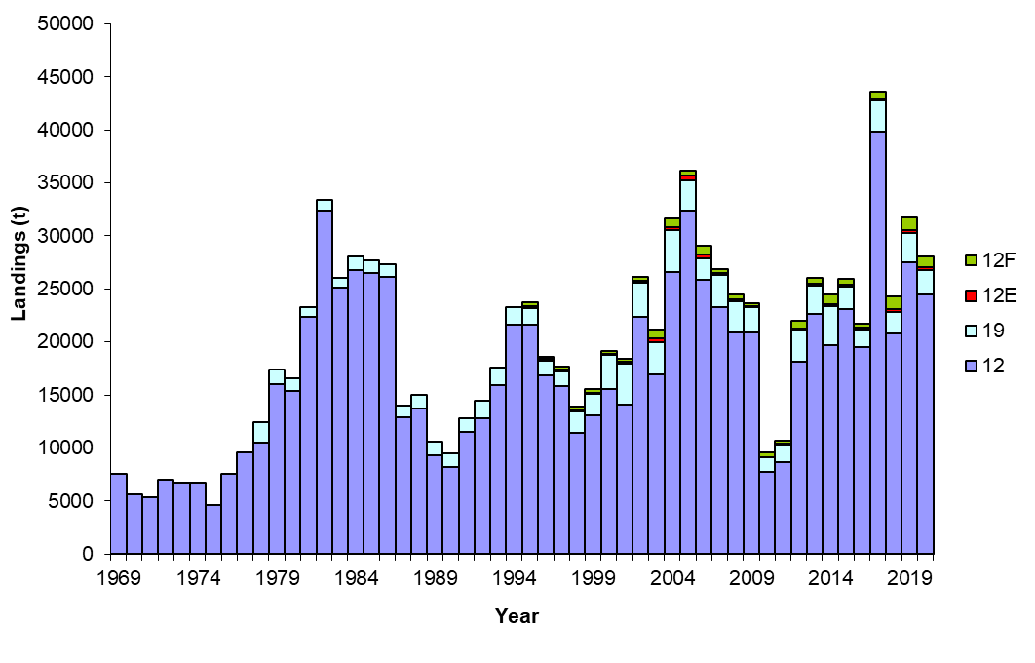

Figure 2. Landings (tonnes; t) in the southern Gulf of St. Lawrence snow crab fishery by fishing area from 1969 to 2020.

Landings in Area 12 were 24,525 t from a revised quota of 27,435 t (Tables 1 and 2; Figure 2). The fishing effort estimated from logbooks has varied from 161,148 to 556,125 trap hauls between 1987 and 2020, with the lowest effort in 2010 and the highest effort in 2020 (Hébert et al. 2020).

Table 2. Quota and landings (tonnes; t), catch per unit of effort (CPUE; kg/trap-haul), fishing effort (trap hauls), soft-shelled crab percentages, and associated closed grids for the snow crab fishery in Area 12, 2012 to 2020.

| Fishery descriptor | 2012 | 2013 | 2014 | 2015 | 2016 | 2017 | 2018 | 2019 | 2020 |
| --- | --- | --- | --- | --- | --- | --- | --- | --- | --- |
| Quota (t) 1 | 18,143 | 22,548 | 19,409 | 23,021 | 19,393 | 39,651 | 20,909 | 28,051 | 27,435 |
| Landings (t) | 18,159 | 22,645 | 19,633 | 23,080 | 19,499 | 39,825 | 20,769 | 27,554 | 24,668 |
| CPUE (kg/trap-haul) | 68.0 | 76.4 | 61.8 | 67.9 | 64.0 | 72.0 | 44.2 | 55.5 | 44.1 |
| Effort (trap hauls) | 267,044 | 296,398 | 317,689 | 339,912 | 304,624 | 553,125 | 469,887 | 496,468 | 556,125 |
| Soft-shelled crab (%) in catches 2 | 3.7 | 2.8 | 4.4 | 4.9 | 5.3 | 6.0 | 4.4 | 5.2 | NA |
| Grids closed (total of 323) | 7 | 5 | 8 | 41 | 5 | 57 | 43 | 93 | NA |

1Since 2012, quotas were revised for interannual quota adjustments, reconciliations, and re-distribution of the scientific quota among areas, the revised quotas do not necessarily correspond to the TAC in the notice to harvesters.  
2 The percentages are based on durometer readings < 68. Catches are defined as male crabs of all sizes.

3 Grids closed according to the soft-shelled crab protocol. Additional closures to minimize fishery interactions with North Atlantic right whales are not accounted for in this table.

The 2020 landings in Area 19 were 2,284 t from a revised quota of 2,287 t (Tables 1 and 3; Figure 2). The fishing effort in Area 19 has varied from 11,138 to 56,517 trap hauls between 1987 and 2020, with the lowest effort in 2010 and the highest effort in 2004 (Hébert et al. 2020). The effort in 2020 was 22,458 trap hauls, a decrease from 2019 (Table 3).

Table 3. Quota and landings (tonnes; t), catch per unit of effort (CPUE; kg/trap-haul), fishing effort (trap hauls), white crab percentages, and associated closed sectors for the snow crab fishery in Area 19, 2012 to 2020.

| Fishery descriptor | 2012 | 2013 | 2014 | 2015 | 2016 | 2017 | 2018 | 2019 | 2020 |
| --- | --- | --- | --- | --- | --- | --- | --- | --- | --- |
| Quota (t) 1 | 2,907 | 2,654 | 3,745 | 2,130 | 1,701 | 2,945 | 2,046 | 2,792 | 2,287 |
| Landings (t) | 2,906 | 2,657 | 3,745 | 2,129 | 1,701 | 2,944 | 2,048 | 2,792 | 2,284 |
| CPUE (kg/trap-haul) | 178.1 | 148.5 | 147.4 | 144.8 | 142.5 | 142.8 | 156.1 | 112.7 | 101.7 |
| Effort (trap hauls) | 16,317 | 17,890 | 25,407 | 14,703 | 11,937 | 20,616 | 13,120 | 24,518 | 22,458 |
| White crab (%) in catches 2 | 4.5 | 3.0 | 1.0 | 5.5 | 8.2 | 11.6 | 8.8 | 20.9 | NA |
| Sectors closed3 | 0/9 | 0/9 | 0/9 | 2/9 | 4/9 | 3/9 | 1/9 | 4/9 | NA |

1Since 2012, quotas were revised for interannual quota adjustments, reconciliations, and re-distribution of the scientific quota among areas, the revised quotas do not necessarily correspond to the TAC in the notice to harvesters.  
2 The percentages are based on durometer readings < 72. Catches are defined as male crabs of all sizes.  
3 Total number of sectors was changed from 4 to 9 in 2009.

The 2020 landings in Area 12E were 234 t from a revised quota of 238 t (Tables 1 and 4; Figure 2). The fishing effort in Area 12E has varied from 1,825 to 10,074 trap hauls between 1995 and 2020, with the lowest effort in 2010 and the highest effort in 2006 (Hébert et al. 2020). The fishing effort in Area 12E increased from 3,415 trap hauls in 2019 to 5,098 trap hauls in 2020.

Table 4. Quota and landings (tonnes; t), catch per unit of effort (CPUE; kg/trap-haul), fishing effort (trap hauls), soft-shelled crab percentages, and associated closed grids for the snow crab fishery in Area 12E, 2012 to 2020.

| Fishery descriptor | 2012 | 2013 | 2014 | 2015 | 2016 | 2017 | 2018 | 2019 | 2020 |
| --- | --- | --- | --- | --- | --- | --- | --- | --- | --- |
| Quota (t) 1 | 251 | 204 | 170 | 189 | 144 | 199 | 266 | 217 | 238 |
| Landings (t) | 185 | 204 | 178 | 192 | 144 | 203 | 260 | 224 | 234 |
| CPUE (kg/trap-haul) | 32.9 | 40.1 | 47.3 | 65.8 | 51.5 | 60.9 | 46.6 | 65.7 | 45.9 |
| Effort (trap hauls) | 5,623 | 5,097 | 3,765 | 2,918 | 2,796 | 3,333 | 5,579 | 3,415 | 5,098 |
| Soft-shelled crab (%) in catches 2 | 3.3 | 15.9 | 7.8 | 9.8 | 1.1 | 2.0 | 4.6 | 3.1 | NA |
| Grids closed (total of 8) | 0 | 0 | 0 | 0 | 0 | 0 | 0 | 0 | NA |

1Since 2012, quotas were revised for interannual quota adjustments, reconciliations, and re-distribution of the scientific quota among areas, the revised quotas do not necessarily correspond to the TAC in the notice to harvesters.  
2 The percentages are based on durometer readings < 68. Catches are defined as male crabs of all sizes.

In Area 12F, the landings were 1,084 t from a revised quota of 1,192 t (Tables 1 and 5; Figure 2). The fishing effort in Area 12F has varied from 4,437 to 23,163 trap hauls between 1995 and 2020, with the lowest effort in 2002 and the highest effort in 2014 (Hébert et al. 2020). The fishing effort increased from 18,083 trap hauls in 2019 to 22,168 trap hauls in 2020.

Table 5. Quota and landings (tonnes; t), catch per unit of effort (CPUE; kg/trap-haul), fishing effort (trap hauls), soft-shelled crab percentages, and associated closed sectors for the snow crab fishery in Area 12F, 2012 to 2020.

| Fishery descriptor | 2012 | 2013 | 2014 | 2015 | 2016 | 2017 | 2018 | 2019 | 2020 |
| --- | --- | --- | --- | --- | --- | --- | --- | --- | --- |
| Quota (t) 1 | 706 | 543 | 906 | 516 | 373 | 680 | 1,218 | 1,155 | 1,192 |
| Landings (t) | 706 | 543 | 882 | 510 | 381 | 684 | 1,183 | 1,166 | 1,084 |
| CPUE (kg/trap-haul) | 41.8 | 49.0 | 38.1 | 38.2 | 43.9 | 72.6 | 69.1 | 64.5 | 45.2 |
| Effort (trap hauls) | 16,890 | 11,086 | 23,163 | 13,351 | 8,667 | 9,421 | 17,120 | 18,083 | 22,168 |
| Soft-shelled crab (%) in catches 2 | 9.4 | 2.4 | 1.7 | 3.3 | 10.4 | 1.9 | 1.3 | 2.1 | NA |
| Sectors closed (total of 3) | 0 | 0 | 0 | 0 | 0 | 0 | 0 | 0 | NA |

1Since 2012, quotas were revised for interannual quota adjustments, reconciliations, and re-distribution of the scientific quota among areas, the revised quotas do not necessarily correspond to the TAC in the notice to harvesters.  
2 The percentages are based on durometer readings < 68. Catches are defined as male crabs of all sizes.

Catch per unit of effort (CPUE; expressed as kilogram per trap-haul (kg/th)) is considered an index of fishery performance and is calculated directly from logbook data as the ratio of total landings (kg) to total effort (trap-hauls). CPUE values are not standardized and do not account for changes in management measures and fishing practices and as a result may not be directly proportional to biomass. The fishery catch per unit effort indices are not used to infer on abundance of the commercial adult male snow crab. The unstandardized catch per unit effort from the fishery correlates weakly with the estimated biomass from the assessment. This results in differences in perception of stock abundance based on fishing industry observations (catch per unit of effort variations within season and between years) from those of the assessment.

Average CPUE during the 2020 fishery decreased in all areas compared to 2019 (Figure 3).

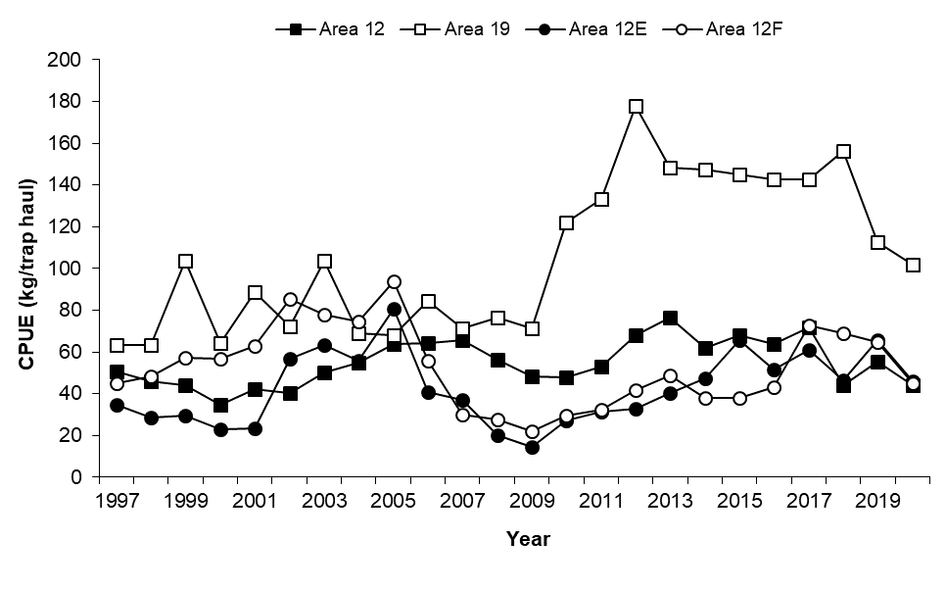

Figure 3. Catch per unit effort (CPUE; kg / trap-haul) in the southern Gulf of St. Lawrence snow crab fishery, Areas 12 (black squares), 19 (open squares), 12E (black circles) and 12F (open circles), based on logbooks, 1997 to 2020.

## ASSESSMENT

Snow crab in the sGSL is considered as a single stock unit for assessment purposes. This stock unit comprises snow crab fishing areas 12, 19, 12E, and 12F.

Details of the snow crab survey design and protocol can be found in DFO 2012a. In 2020, the number of sampling stations remained targeted at 355. As per the recommendations from the 2014 scientific peer review (DFO 2014a), the 350 successful sampling stations from the 2019 trawl survey were used as fixed stations and a new set of five sampling stations (i.e. the three stations that were abandoned and the two sampling stations that were conducted outside their assigned grids in 2019) was generated randomly. The survey was conducted from the vessel Avalon Voyager II, a new vessel used since 2019. A total 353 stations were successfully trawled in 2020; two sampling square grids had to be abandoned due to failures to successfully trawl the area. The survey was conducted between July 11 and September 10, 2020. Sampling protocols were identical to previous years (Hébert et al. 2020).

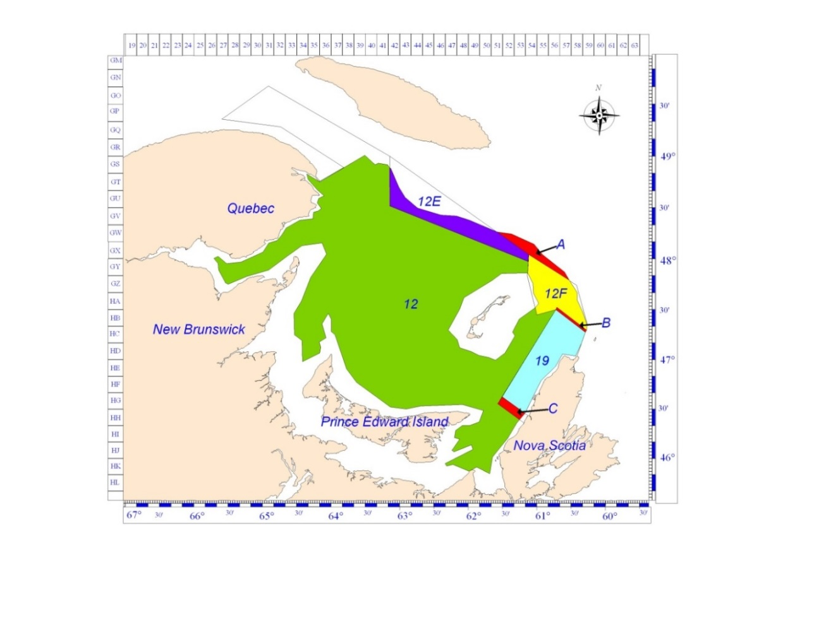

Figure 4. The survey and estimation polygon of 57,842.8 km2 used for the 2020 snow crab stock assessment in the southern Gulf of St. Lawrence (all of the coloured areas) and corresponding estimation polygons for the four crab fishing areas (12, 12E, 12F, and 19). The unassigned zone north of areas 12E and 12F (label A) and buffer zones (labels B and C) are also shown.

### Stock Trends and Status, and Recent Survey Issues

Stock status is assessed from various abundance and biomass indices calculated using kriging with external drift (KED) with depth as a secondary variable (DFO 2012a; Wade et al. 2014) applied to standardized survey catches (numbers or weights per trawl swept area. Commercial crab biomass (legal-sized adult males) were sub-divided by residual biomass (hard-shelled adult males of legal size remaining after the fishery) and recruitment biomass (soft-shelled adult males >= 95 mm CW referred to as R-1 that will be available to the fishery the following fishing season). Predictors of four- three- and two-year fishery recruitment indices are also estimated, referred to as R-4, R-3 and R-2, respectively. A population recruitment index is estimated from survey catches of small male crabs (34-44 mm CW), which take at least six years to reach the commercial size.

The change in survey vessel in 2019 was accompanied by significant increases of 30-40% among male and mature female snow crab from 35mm to 95 mm CW (Figure 5). These catch increases strongly suggest an increase in survey catchability, as natural processes such as recruitment, migration or low mortality cannot account for increases over such a broad size range. Investigations suggested that an increase in the duration of latent bottom trawling phase during hauling of the net, referred to as the passive trawling phase, was at least partially to blame, though it could only account for 12% of the increase (Ref). Protocol changes brought in during the 2020 survey resulted in a modest 5-10% catch decrease in the above groups.

In contrast, commercial sized-crab abundance and biomass remained stable levels over the same period (2018-2020). The behavior of the trawl during the passive trawling phase, in contrast to regular trawling, is not well characterized. The uncertainty surrounding the mechanisms underlying the catchability increase among sub-legals, plus the complex dynamics of the commercial stock, means that quantifying their impact on the commercial component is difficult to resolve.

Hypotheses were proposed to explain the stability legal-sized component of the stock crab in the face of the survey catchability increases seen in sub-legal crab.

Among the probable hypotheses is 1) a strong increase in fishery-related mortality in 2019 and 2020, effectively tempering a survey catch increase among legal-sized crab that would otherwise have been observed; and 2) that the 2019 survey catchability increase is size-dependent and strongly focused on sub-legal sizes. Other proposed hypotheses were en masse crab migration, or localized differences in local catchability. However, neither of these hypotheses can account for the strength of the increases, nor their restricted association with sub-legal sizes.

Indicateurs de bias

* Residuelle+débarquements versus estimé biomasse commerciale

Différences entre sous-légaux/femelles et crabes commerciaux

Mention des hypothèses considérées pour expliquer la différence dans les « signaux » (brief with more explanations in the res doc).

Two indirect methods of estimating the bias on the commercial stock were proposed. One was a classical Leslie analysis, which estimated pre-fishery biomass based upon trends in observed weekly fishery CPUEs, and the other based on the difference between the 2020 residual biomass and its predicted value based on 2020 landings and the 2019 total commercial biomass with a 30% annual mortality. Estimated overestimation biases for 2020 were estimated 14.X% using the Leslie analysis and X% using the residual biomass method, relative to 2018….

**Summary and consequences:**

The point estimate for the biomass of commercial-sized adult males in the sGSL from the 2020 trawl survey was estimated at 77,748 t (Table 6; Figure 6). ~~The 2020 commercial biomass in the sGSL is similar to the 2019 estimate.~~

The estimated recruitment to the fishery at the time of the 2020 survey represented 75% of the commercial biomass estimate. The remaining 25% is the residual biomass estimate. ~~was 58,438 t, comprising 75% of the commercial biomass (Table 6; Figure 6). The recruitment to the fishery in 2020 is similar to the 2019 estimate. The residual biomass (carapace conditions 3 to 5) of commercial-sized adult male crabs after the 2020 fishery was estimated at 19,107 t, a decrease of 5.8% compared to the 2019 estimate (Table 6; Figure 5).~~

|  |  |
| --- | --- |
| Macintosh HD:Users:crustacean:Desktop:Stock-Assessment-2020:size-frequencies 2018-2019 - males - english.pdf | Macintosh HD:Users:crustacean:Desktop:Stock-Assessment-2020:size-frequencies 2018-2019 - females - english.pdf |
| Figure 5. Comparison of average size-frequencies from the 2018 (lines) and 2019 (grey bars) snow crab surveys for male (left panel) and female (right panel) snow crab. Vertical dash red line indicates the 95 mm CW legal size. | |

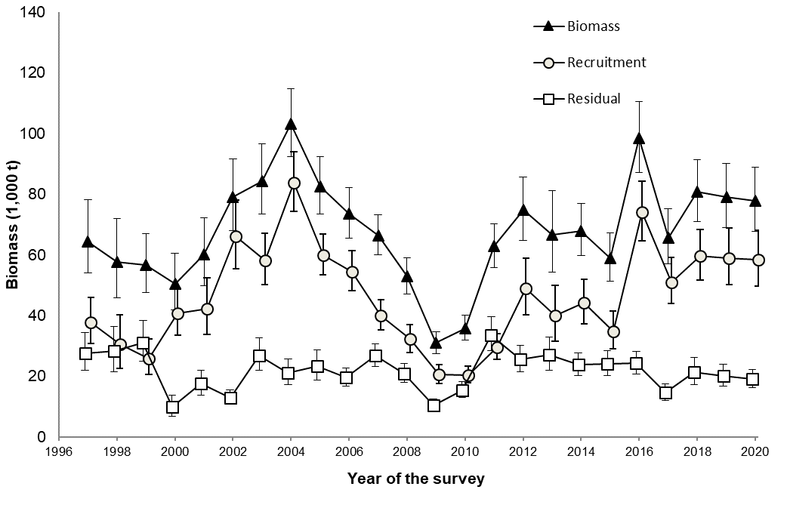

Figure 5. Total commercial biomass (black triangles), recruitment commercial biomass (open circles), and residual commercial biomass (open squares; in 1,000 t; means with 95% confidence intervals) in the southern Gulf of St. Lawrence, 1997 to 2020.

Table 6. Total commercial, recruitment, and residual biomass (t; means with 95 % confidence intervals) of commercial-sized adult male crabs (>= 95 mm carapace width) in the southern Gulf of St. Lawrence, 2009 to 2020.* Data from the 2019 and 2020 surveys are likely overestimated.

| Year of the survey | Commercial Biomass (t) | Recruitment Biomass (t) | Residual Biomass (t) |
| --- | --- | --- | --- |
| 2009 | 31,015 27,519-34,829 | 20,618 17,747-23,818 | 10,454 8,687-12,474 |
| 2010 | 35,929 32,049-40,147 | 20,477 17,815-23,423 | 15,490 13,022- 18,289 |
| 2011 | 62,841 55,985-70,299 | 29,643 25,676-34,045 | 33,679 28,430-39,613 |
| 2012 | 74,778 64,881-85,748 | 49,010 40,382-58,931 | 25,615 21,607-30,147 |
| 2013 | 66,709 54,294-81,108 | 39,988 31,504-50,055 | 27,092 22,041-32,952 |
| 2014 | 67,990 59,802-76,978 | 44,285 37,440-52,014 | 23,863 20,356-27,799 |
| 2015 | 58,927 51,368-67,278 | 34,982 29,145-41,643 | 24,108 20,290-28,429 |
| 2016 | 98,394 87,150-110,677 | 74,124 64,811-84,392 | 24,309 20,876-28,143 |
| 2017 | 65,738 57,221-75,157 | 51,127 43,976-59,103 | 14,650 12,134-17,534 |
| 2018 | 80,746 70,984-91,467 | 59,609 51,755-68,310 | 21,432 17,271-26,291 |
| 2019* | 79,066* 69,072-90,091 | 58,995* 50,215-68,863 | 20,291* 16,940-24,109 |
| 2020* | 77,748*  67,706-88,852 | 58,438*  49,759-68,189 | 19,107*  16,235-22,339 |

In the 2020 trawl survey, concentrations of commercial-sized adult males were located in Bradelle Bank, in Shediac valley, in Chaleur Bay, in the central and southern parts of the Magdalen Channel, in Area 12F and in the southeastern part of the sGSL (Figure 6). The spatial distributions of commercial-sized adult males have varied annually during increasing and decreasing phases of the commercial biomass (Figure 7).

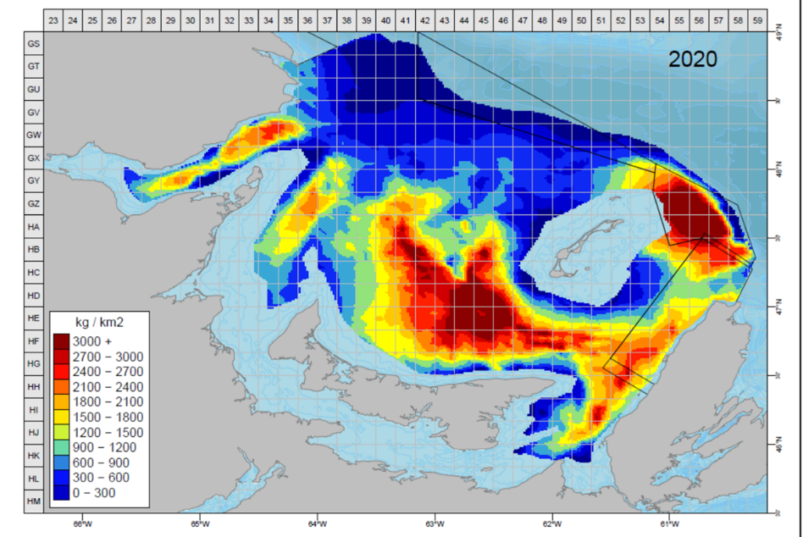

Figure 6. Density (kg per km2) contours of commercial-sized adult male crabs with a carapace width equal to or larger than 95 mm in the southern Gulf of St. Lawrence in 2020, based on the snow crab trawl survey.

The proportions of the 2020 commercial biomass estimates in the snow crab fishing areas (12, 19, 12E and 12F), the two buffer zones (between Areas 12F and 19, between Areas 12 and 19) and the unassigned zone (north of Areas 12E and 12F), as shown in Figure 4, are summarized in Table 7. The majority (81.6%) of the biomass in 2020 was located in Area 12, followed by Area 19, 12F, 12E (Table 7). The estimates of the commercial biomass by fishing area have greater uncertainty than for the sGSL overall. This higher uncertainty is more pronounced in small fishing areas, as they contain fewer sampling stations.

Table 7. Estimates of commercial biomass (t; means and 95% confidence intervals) in 2020 for the southern Gulf of St. Lawrence estimation polygon of 57,842.8 km2 and for each of the snow crab fishing areas 12, 19, 12E, 12F, the buffer zones, and the unassigned zone. Also shown are the percentages of the mean estimated biomass in each of the four snow crab fishing areas to the sum of the biomass estimates in those four zones in 2020. Zone labels are referenced to those in Figure 4.

| Area | Surface area (km2) | Commercial biomass (t) | | % in 2020 |
| --- | --- | --- | --- | --- |
| Mean | 95% confidence intervals |
| Southern Gulf 1 | 57,842.8 | 77,748 | 67,706 – 88,852 | na |
| Area 12 | 48,074.0 | 62,422 | 53,667 – 72,190 | 81.6 |
| Area 19 | 3,813.0 | 6,897 | 5,011 – 9,261 | 9.0 |
| Area 12E | 2,436.9 | 687 | 86 – 2,579 | 0.9 |
| Area 12F | 2,426.8 | 6,480 | 4,939 – 8,350 | 8.5 |
| Subtotal of crab fishing areas | 56,750.7 | 76,486 | na | 100 |
| Unassigned zone above 12E and 12F (label A) | 667.9 | 433 | 76 – 1,417 | na |
| Buffer zone  19 / 12F (label B) | 134.2 | 325 | 153 - 610 | na |
| Buffer zone 12 / 19 (label C) | 289.5 | 627 | 205 – 1,268 | na |
| Total of all individual area estimates 1 | 57,842.7 | 77,871 | na | na |

1 Small difference in the sum of all individual area estimates compared to the southern Gulf estimate is due to rounding of intermediate calculations.

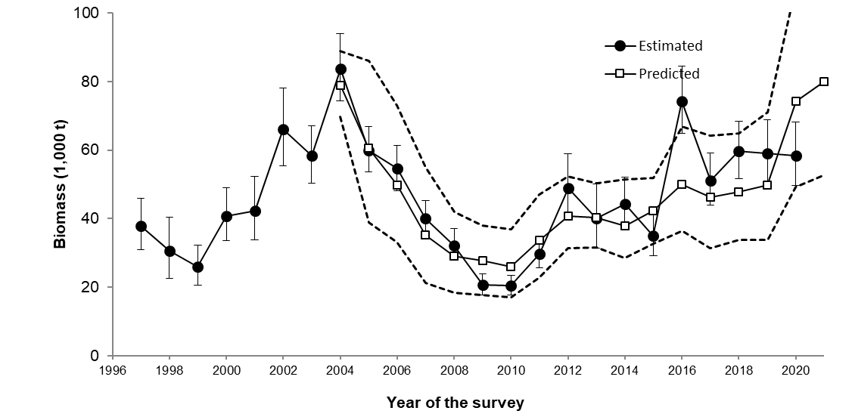

Figure 9. Estimated (black circles are the means with 95% confidence interval vertical bars) and predicted (open squares are the means with the 95% confidence interval bands as dashed lines) biomasses of R-1 (adult male crabs >= 95 mm carapace width of carapace condition 1 and 2) snow crab in the year of the survey, 1997 to 2020. The predicted abundances are based on a relationship to the estimated abundances of R-2 (adolescent male crabs with a carapace width larger than 83 mm) in the previous year. Prediction of R-1 biomass for 2021 is based on abundances of R-2 estimated in 2020 and shown in Figure 9.

The high predicted value for 2021 is driven by the high estimated abundance of R-2 crab estimated from the survey in 2020; the extent to which the high recruitment will be realized in 2021 is very uncertain resulting from the change in vessel since 2019.

Estimated abundances of R-3 and R-2 stages in 2019 and 2020 are greater than the estimated abundances of R-4 and R-3 stages, respectively in 2018, an observation which is inconsistent with cohort tracking and accounting for mortality over the years (Figure 10).

### Environmental Considerations

In September 2020, near-bottom temperatures were near the mean value of the period 1991 to 2020 in the central portion of Area 12 as well as in the western part Chaleur Bay. However, the bottom waters in large portions of Area 12, Area 19, the deeper parts of Area 12E and 12F, and both entrances of Northumberland Strait were significantly warmer than normal. The channels connecting the slope of the Laurentian Channel to the mouth of Chaleur Bay were also warmer than normal. Colder-than-normal bottom waters were only present in a small area south of Shediac Valley and in St. George’s Bay.

In September 2020, the snow crab habitat index (bottom area with temperatures from -1 to 3°C) was the fourth lowest of the 1971-2020 time series (Fig. 13). It was 10% below the 1991-2020 average in 2020 and is similar to the 2019 value which was down 11% from the 2018 value. The mean temperature (1.3°C) within the defined snow crab habitat area index (-1 to 3°C) in 2020 increased by about 0.3°C compared to 2019 (1.0ºC, Fig. 13). Looking at the last three decades, the mean temperature was at the highest of the time series in 2012, decreased in 2013 and 2014, and remained above the normal since then.

Snow crab is a stenothermic species with a preference for colder water temperatures. A temperature regime shift from cold to warm may have impacts on population dynamics of snow crab such as shortened reproductive cycles, increased per capita fecundity, and increased size at maturity, greater natural mortality, spatial contraction of habitat, and skewed sex ratio for reproduction. The outcome of climate change on snow crab population dynamics can be relatively abrupt and even detrimental, and the direction of the effect may be difficult to predict (Sainte-Marie et al. 2008).

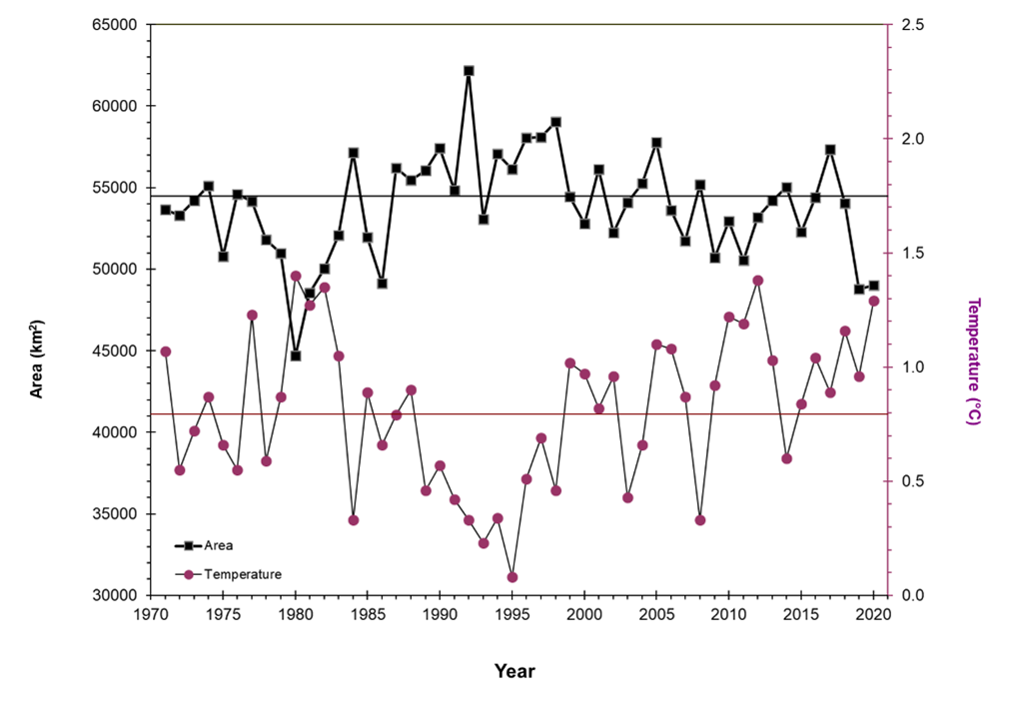

Figure 13. Habitat area index ((water temperatures of -1 to 3 ºC; km²; square symbols) for commercial-sized adult male snow crab in the southern Gulf of St. Lawrence and the mean temperature (ºC; circle symbols) within the index area from 1971 to 2020.

### Sources of Uncertainty

The estimated abundances of snow crab, all life stages, in the assessment model are considered to be an unbiased, proportional index of the snow crab population in the sGSL over the time series 1997 to 2020. As such, the catchability for commercial-sized male snow crab is assumed to be constant over the time series and for the purposes of this assessment equal to one.

Sub-legal male and mature female indices from the 2019 and 2020 surveys are likely over-estimated by 30-40% with respect to the 2018 survey.

Consequently, population and fishery recruit and female abundance indices for 2019 and 2020 are likely over-estimated by 30-40%.

This raises the concern that commercial abundance and biomass indices may be over-estimated in 2019 and 2020, relative to 2018.

However, there are many known issues with this interpretation of survey indices. Firstly, the survey has undergone multiple areal expansions into more marginal crab habitat, requiring spatial extrapolations of more central observations over these marginal areas for years prior to 2012. Secondly, the survey has been redesigned in 2006 and 2012, leading a to redistributions of its survey sampling stations. Thirdly, five survey vessels have been used, with different crews, increasing engine power, and variations in fishing protocol (Hébert et al. 2019).

These unquantifiable issues weaken the assumption of temporal homogeneity of the time series, and thus our ability to track population trends and biomass estimates which have comparable scales with respect to the harvest control rule limits and reference points.

Strong increases in survey catches in 2019 among females and sub-legal males cannot be explained by known population processes, suggesting that an increase in survey catchability had accompanied the introduction of the new survey vessel. The previous stock assessment proposed an unaccounted latent trawling phase as a likely cause, though protocol changes that ostensibly rectified this issue resulted in very similar catches in the 2020 survey. Thus, a mechanistic explanation for this increase is presently lacking. Benoit and Cadigan (2013), using the sGSL September multi-species survey as a reference, suggested that the vessel change in the snow crab survey in 2013 resulted in a lower catchability for commercial snow crab. Taken together, these observations suggest that catches on board the Jean Mathieu may have been underestimated relative to the Marco Michel and Avalon Voyager II.

Independent of vessel changes, the current practice of relocating survey stations to alternate locations when trawl damage is incurred may lead to progressive preferential sampling of trawlable bottoms, year upon year. Differences in crab density or catchability between trawlable and less trawlable areas can lead to differences in survey catches, thus potentially biasing abundance and biomass indices.

Predicting recruitment to the fishery is uncertain because of a number of factors including variations in mortality, growth among stages and the variation in the proportion of pre-recruits that molt in any given year. Recruitment to the fishery for snow crab is highly variable from year to year depending on environmental conditions, predation and population levels. Prediction of a given size of male crab belonging to the near-future recruitment population (R-1, R-2 and R-3) is difficult because of a number of factors including variations in mortality and catchability, growth among stages and the variability in the proportion of pre-recruits that molt in a given year, which increases uncertainty of predicted and measured abundance of recruitment to the fishery.

Environmental conditions in the sGSL vary annually and these changes can affect a number of life history processes including molting and growth, reproduction, and larval development. Warming of the deep water of the Laurentian Channel may influence bottom temperatures in adjacent areas and the impacts on the snow crab population remain uncertain. Snow crab in the peripheral areas of the sGSL adjacent to the slope of the Laurentian Channel and the troughs along western Cape Breton Island would be particularly susceptible to these warming trends.

## CONCLUSIONS AND ADVICE

Options discutées pour remédier au biais potential

Retour sur « inaction » en 2019 croyant avoir résolu le biais

Conséquences (court et long terme) possibles si status quo

Analyse de risque selon différents biais possibles

|  |  |  |  |  |
| --- | --- | --- | --- | --- |
| Bias on the commercial biomass estimate | Biomass estimate (t)  (corrected for bias) | Residual biomass < B lim | Commercial biomass < B USR | Exploitation rate (%)  assuming TAC of 31,410 t |
| 0% | 77,748 t | 0% | 0% | 40.4% |
| 5% | 73,861 t | 0.7% | 0% | 42.5% |
| 10% | 69,973 t | 4.2% | 0% | 44.9% |
| 15% | 66,086 t | 17.4% | 0.1% | 47.5% |
| 20% | 62,198 t | 44.8% | 0.4% | 50.5% |

Mesures correctives et prochaines étapes

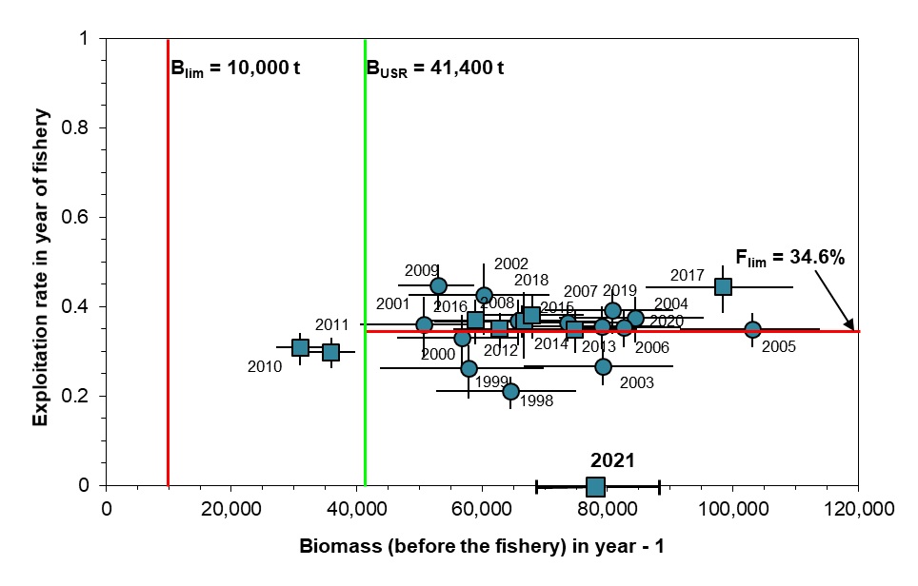

Figure 14. Trajectory of stock abundance (biomass of commercial-sized adult male crabs as estimated from the trawl survey in the year before the fishery) versus exploitation rate in the fishery year for snow crab from the southern Gulf of St. Lawrence. Year of the fishery is labeled on the figure. Error bars are 95% confidence intervals. Circle symbols are biomass and exploitation rate levels used to define the reference points. The squares are the years when the reference points were used within the PA to decide on the fishery quota. The biomass estimate available for the 2021 fishery (with 95% confidence interval) is also shown.

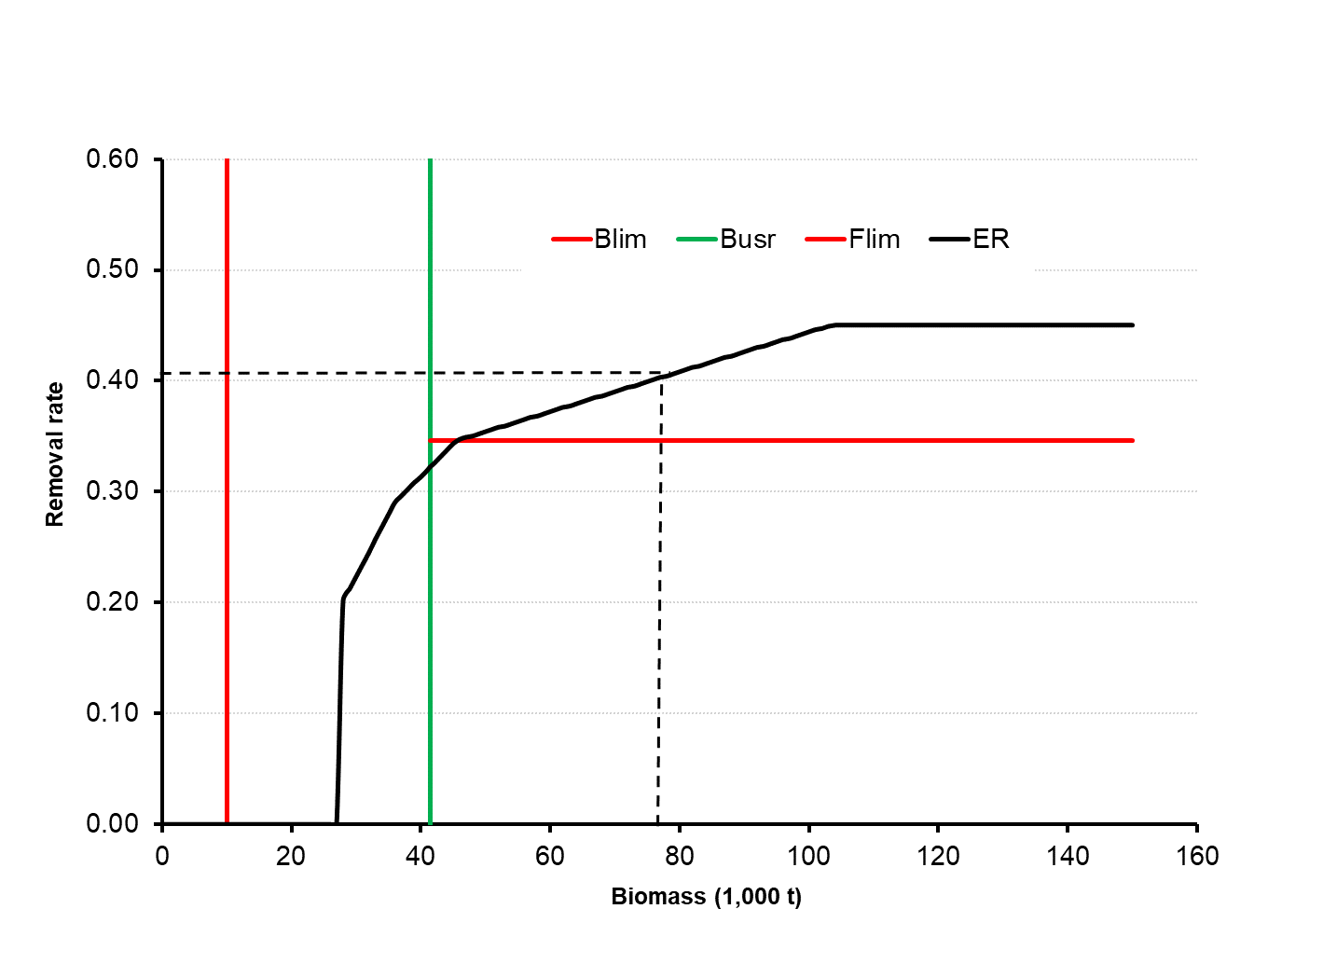

Figure 15. Harvest decision rule (solid black line; proportional variant 4; DFO 2014b) for the southern Gulf of St. Lawrence snow crab fishery and corresponding exploitation rate (0.404) for the 2021 fishery resulting from the commercial biomass estimate of 77,748 (dashed-dotted line).

|  |  |  |  |
| --- | --- | --- | --- |
| 41,730 | 0.5 | 1 | 89,779 (57,680-122,010) |
| 90,230 | 1 | 0.5 | 41,227 (22,657-73,508) |
|  |  |  |  |

The biomass of commercial-sized adult males is considered to be at a high level and in the healthy zone of the PA. There is a broad distribution of snow crab in the sGSL and continued positive signs of sustained recruitment and high female abundances.

## LIST OF MEETING PARTICIPANTS

| Name | Affiliation |
| --- | --- |
|  |  |
|  |  |
|  |  |
|  |  |
|  |  |
|  |  |
|  |  |
|  |  |
|  |  |
|  |  |
|  |  |
|  |  |
|  |  |
|  |  |
|  |  |
|  |  |
|  |  |
|  |  |
|  |  |
|  |  |
|  |  |
|  |  |
|  |  |
|  |  |
|  |  |
|  |  |
|  |  |
|  |  |
|  |  |
|  |  |
|  |  |
|  |  |
|  |  |
|  |  |
|  |  |
|  |  |
|  |  |
|  |  |
|  |  |
|  |  |
|  |  |
|  |  |
|  |  |
|  |  |
|  |  |

## SOURCES OF INFORMATION

This Science Advisory Report is from the February 10-11, 2021 regional advisory meeting on the stock assessment of the southern Gulf of St. Lawrence snow crab stock to 2020 and catch advice for the 2021 fishery. Additional publications from this meeting will be posted on the [Fisheries and Oceans Canada (DFO) Science Advisory Schedule](http://www.isdm-gdsi.gc.ca/csas-sccs/applications/events-evenements/index-eng.asp) as they become available.

Benoît, H.P., and Cadigan, N. 2016. Trends in the biomass, distribution, size composition and model-based estimates of commercial abundance of snow crab (*Chionoecetes opilio*) based on the multi-species bottom trawl survey of the southern Gulf of St. Lawrence, 1980-2014. DFO Can. Sci. Advis. Sec. Res. Doc. 2015/084. v + 25 p.

DFO. 2009. [A fishery decision-making framework incorporating the Precautionary Approach](http://www.dfo-mpo.gc.ca/reports-rapports/regs/sff-cpd/precaution-eng.htm).

DFO. 2010. [Reference points consistent with the precautionary approach for snow crab in the southern Gulf of St. Lawrence](http://www.dfo-mpo.gc.ca/csas-sccs/publications/sar-as/2010/2010_014-eng.htm). DFO Can. Sci. Advis. Sec. Sci. Advis. Rep. 2010/014.

DFO 2012a. [Proceedings of the Gulf Region Science Peer Review Framework Meeting of Assessment Methods for the Snow Crab Stock of the southern Gulf of St. Lawrence; November 21 to 25, 2011](http://www.dfo-mpo.gc.ca/csas-sccs/Publications/Pro-Cr/2012/2012_023-eng.html). DFO Can. Sci. Advis. Sec. Proceed. Ser. 2012/023.

DFO. 2012b. [Revised reference points for snow crab to account for the change in estimation area of the southern Gulf of St. Lawrence biological unit](http://www.dfo-mpo.gc.ca/csas-sccs/Publications/SAR-AS/2012/2012_002-eng.html). DFO Can. Sci. Advis. Sec. Sci. Advis. Rep. 2012/002.

DFO. 2014a. [Assessment of snow crab in the southern Gulf of St. Lawrence (Areas 12, 19, 12E and 12F) and advice for the 2014 fishery](http://www.dfo-mpo.gc.ca/csas-sccs/Publications/SAR-AS/2014/2014_008-eng.html). DFO Can. Sci. Advis. Sec. Sci. Advis. Rep. 2014/008.

DFO. 2014b. [Assessment of candidate harvest decision rules for compliance to the Precautionary Approach framework for the snow crab fishery in the southern Gulf of St. Lawrence](http://www.dfo-mpo.gc.ca/csas-sccs/publications/sar-as/2014/2014_007-eng.html). DFO Can. Sci. Advis. Sec. Sci. Advis. Rep. 2014/007.

DFO. 2019. [Snow crab in the Southern Gulf of St. Lawrence – crab fishing areas 12, 12E, 12F and 19. Date modified: 2019-07-12.](http://www.dfo-mpo.gc.ca/fisheries-peches/commercial-commerciale/atl-arc/2019/snow-crab-crabe-neige-0504_b-eng.html)

Hébert, M., Surette, T., Landry, J.-F., and Moriyasu, M. 2020. Review of the 2019 snow crab (*Chionoecetes opilio*) fishery in the southern Gulf of St. Lawrence (Areas 12, 19, 12E and 12F). DFO Can. Sci. Advis. Sec. Res. Doc. 2020/070. iv + 46 p.

Sainte-Marie, B., Gosselin, T., Sévigny, J.-M., and Urbani, N. 2008. The snow crab mating system: opportunity for natural and unnatural selection in a changing environment. Bulletin of Marine Science 83: 131-161.

Wade, E., Moriyasu, M., and Hébert, M. 2014. [Methods and models used in the 2012 assessment of the snow crab (*Chionoecetes opilio*), stock in the southern Gulf of St-Lawrence](http://www.dfo-mpo.gc.ca/csas-sccs/publications/resdocs-docrech/2013/2013_113-eng.html).DFO Can. Sci. Advis. Sec. Res. Doc. 2013/113.

## THIS REPORT IS AVAILABLE FROM THE:

Centre for Science Advice (CSA)  
Fisheries and Oceans Canada  
Gulf Region  
P.O. Box 5030  
Moncton, NB  
E1C 9B6

Telephone: 506-961-1146  
E-Mail: [csas-sccs@dfo-mpo.gc.ca](mailto:csas-sccs@dfo-mpo.gc.ca)  
Internet address: [w](http://www.dfo-mpo.gc.ca/csas-sccs/" \o "Fisheries and Oceans Canada / Canadian Science Advisory Secretariat)[w](http://www.dfo-mpo.gc.ca/csas-sccs/" \o "Fisheries and Oceans Canada / Canadian Science Advisory Secretariat)[w.d](http://www.dfo-mpo.gc.ca/csas-sccs/" \o "Fisheries and Oceans Canada / Canadian Science Advisory Secretariat)[fo-mpo.gc.ca/csas-sccs/](http://www.dfo-mpo.gc.ca/csas-sccs/" \o "Fisheries and Oceans Canada / Canadian Science Advisory Secretariat)

ISSN 1919-5087  
© Her Majesty the Queen in Right of Canada, 2021



Correct Citation for this Publication:

DFO. 2021. Assessment of snow crab (*Chionoecetes opilio*) in the southern Gulf of St. Lawrence (Areas 12, 19, 12E and 12F) to 2020 and advice for the 2021 fishery. DFO Can. Sci. Advis. Sec. Sci. Advis. Rep. 2021/0XX.

Aussi disponible en français :

MPO. 2021. Évaluation du crabe des neiges (Chionoecetes opilio) du sud du golfe du Saint-Laurent (zones 12, 19, 12E et 12F) jusqu’en 2020 et avis pour la pêche de 2021. Secr. can. de consult. Sci. du MPO. Avis sci. 2021/0XX.